**Warrenbound Game Design Bible**

Table of contents

High Concept/Summary of Game

Game Pitch

Design Goals

Narrative

Gameplay

Art Design

Features to be further discussed

**High Concept**

*Warrenbound*, is a top down stealth game with light RTS elements mixed in. The game takes place in various parts of America, following a herd of rabbits as they journey to find a new warren after their previous one is destroyed. Players will take the role of a rabbit deity who is guiding the herd towards their new home. By using a combination of his deity powers and strategic planning, players will be able to safely guide the herd past dangerous predators and obstacles that stand in the way.

**Genre**

Top down stealth game with light RTS elements

**Gameplay**

Players will be in control of a rabbit deity, who must guide the rabbits through various levels past predators by using distractions. By using the deity’s powers players can interact with objects in the environment to draw a predator’s attention for a short while. Distraction abilities are limited by a power bar, encouraging strategic and conservative gameplay. Allowing a rabbit to be discovered by an enemy will cause it to panic, at which point it will stop listening to your orders. During gameplay players will be able to see both the rabbits and enemies share their thoughts through dialogue. This is to offer insight on what the animal is thinking, what they’re about to do, and foreshadow what’s up ahead in the level.

**Features**

* Narrative told through the animals thoughts and the environment
* Several strategic options on how to navigate past enemies and complete levels
* World is viewed through the paper craft art style to show the simplicity and beauty of nature

**Hardware Platforms and License**

* PC
* Unity License

**Summary**

*Warrenbound* is a game that is driven by its narrative, gameplay and the strategic flexibility it gives players for beating the game.

**Game Pitch**

Forced to abandon their warren because of human construction, a herd of rabbits set off on an adventure to find a new home. With a little help from a greater power, perhaps the rabbits might be able to survive the journey. In this top down stealth game with light RTS elements, play as a rabbit deity who helps guide the rabbits through predator infested areas. Use your deity powers to distract enemies while also influencing the herd’s movements. Be careful through, making too many careless decisions will cause the rabbits to panic and ignore your guidance.

**Design Goals**

Throughout development the hope is that we as a team will be able to achieve certain goals that will help make the game a unique, fun experience. The goals for this game can be summarized into three different points.

*Creating a narrative that is told primarily through gameplay and player observations.

*Design the game to be an artistic reflection of how this game would look in a real world setting.

*Build a stealth system that makes use of the environment and the large number of rabbits players will be able to guide.

We are limited with the amount of time we have to work on this game, but if we make efficient use of our work hours I can see at least some of these goals being completed.

**Narrative**

**Plot Summary**

Near the beginning of summer a construction company prepares the setup of a new mall. The construction happens to take place on top of a rabbit warren, causing its inhabitants to flee their home. With their warren gone, the rabbits become frightened and remain unsure of what to do. Ideally they would like to create a new warren somewhere else but, much of the land past their home is foreign to them. There is some hope as a rabbit deity happens to witness these events and takes pity on the herd. The deity sends them a sign that tells the rabbits that he will guide them to a spot that would be perfect for a new warren. With no other choice left, the rabbits put their faith in the deity to show them the way and keep them safe from predators on their journey.

**The Goal of the Narrative**

The majority of the narrative in Warrenbound won’t be told through cutscenes as the goal will be to have narrative occur alongside gameplay. As mentioned in the design goals the idea is that the narrative will be showcased through character and player actions and reactions. What this means is that the player has the power to decide how the story should unfold. The characters in-game will react to what the player does and act accordingly. Further detail on the two different points will be made in the following sections.

**Narrative through Player Actions**

Remember that players take the role of a rabbit deity who is the one helping the rabbits reach their new home. The base of the deity’s power revolves around guidance and interaction with inanimate objects. By using guidance the deity can tell rabbits when to move and where. Interaction is used to create various distractions that can distract predators allowing a chance for rabbits to sneak past. These two abilities open the door to various different narrative experiences based on how the player uses these powers. This is where level design and the environment are most important because that is where all of the player’s tools and tricks are for distracting predators.

**Narrative through Character Reactions**

In the game characters will be represented by two main parties, the rabbits and the predators. How these two work into the narrative relies on what the player does in-game. Characters may react by saying a small line of dialogue, moving to a new location, or change what they are feeling. For instance, if the player causes the death of a small group of rabbits the others may begin to talk to each other about their doubts in the deity while shivering in fear. This goes for predators as well as they might act happy or proud if they snag a rabbit or frustrated if they can’t find or catch one. For character dialogue from the rabbits that will be dependent on this personality. The rabbits players guide will each have different personality types that will determine how they respond to certain events or actions. A pessimistic rabbit might say depressing things about how the herd will die. While a faithful rabbit might shower the deity with praise for all of his actions.

**Gameplay**

**Gameplay and Mechanics Overview**

Below is a simplified list of all of the major gameplay and mechanic features that will be put into the game. Each will have its own section in the following pages further describing what they are and how it should work. (This is an early work in progress and is subject to change before actual development begins.)

* **Stealth**
  + Top Down View
  + Multiple Pathways
  + Hiding
* **Rabbit Deity**
  + Guiding Multiple Rabbits
    - Sneaking and Sprinting
  + Powers and Power Bar
* **Predators**
  + A.I Routes and Patterns
  + Sight
  + Hearing
* **Win/Lose Conditions**
  + Beating a level
  + Getting caught and mass panic

**Stealth**

The main genre of this game is stealth and as such it follows the basic formula of one where the player is tasked to move from point A to B without being spotted by enemies. Beyond the basics, Warrenbound is more specifically a top down stealth game. As such players will have an overhead view of the map that will allow them to see their characters, enemies, and points of interest. The reason why the top down view was chosen was so that the level can be viewed as a puzzle of sorts. The player is given all of the information they need at the start then it is left to them to try and solve it.

Although unlike most puzzles there will be multiple paths and choices that can lead to the end. For instance one pathway might be a straight shot to the end, but has more enemies nearby while another path is more out of the way and generally safer. It will be up the player and their playstyle to decide how they should go about beating a level.

The last thing to mention to cap off the overall stealth system is how hiding works. Seeing as the games setting is in nature most of the hiding spots will be things such as bushes, natural trenches, trees, etc. The current idea for how hiding in these spots will work is that after you have selected a rabbit or group of rabbits and click on one of these spots they will go there and hide. For hiding spots like bushes and trenches they will hide inside them staying out of natural enemy sight. Spots such as trees or rocks would work a little differently as they can only hide behind them away from where predators are located. Hiding spots will also have limits to the number of rabbits they can feasibly hold. If a hiding spot is ever exceeding its limit it will create noise that will alert nearby predators to check it out.

**Rabbit Deity**

The only entity that the player has full control over is the rabbit deity. The deity can be described as a force that is never physically seen. Still the rabbits believe he exists and follow what they see as his acts of guidance. Guidance is used to move one or multiple rabbits from one spot to another in a level. The current idea for how this will work is similar to how units in RTS games move. You can click on a rabbit to select a single rabbit or click and drag to select multiple rabbits. When players have selected rabbits they just need to click on the spot they want them to move to that location. (Also include a Ctrl click option for selecting rabbits.)

However, depending on which button you click before you tell the rabbits to move will decide if they sneak or sprint to the selected location. Sneak and sprint will work as toggle keys so that whenever the sneak key is on rabbits will only move slowly and quietly. Alternately if the sprint key is on then the rabbits will dash, but make more noise in the process. Another factor that will determine the amount of noise made is the size of the group moving. For example, if one rabbit is moving he will not create too much noise. However, if six rabbits are moving together at once then the noise generated will be much louder making it easier for the group to be heard.

Beyond guidance players also have access to powers that allow them to interact with various objects in the environment. This is used to create distractions that will draw the attention of predators. By using these moments of opportunity to their advantage, players can have an easier time sneaking rabbits past a distracted predator than an alert one.

This is not to say that players can use these powers as frequently as they want because they will be limited by a power bar. Each interaction with an object requires energy from the power bar and when it is empty powers can’t be used. (So no one becomes confused guidance is not considered a power so players can move rabbits as much as they like without draining the power bar.) The initial purpose of the power bar is to prevent spamming distractions and making levels too easy.

**Predators**

The main obstacles that will stand in the player’s way will be the predators. These can include foxes, wolves, large birds, and many more. Each predator will have its own basic routes and patterns that can recognized through player observation. Only by seeing the patterns and using the rabbit deity powers strategically will players be able to avoid being spotted. If a predator catches a rabbit it will take its kill off-screen and that predator will be replaced by a new one of the same species.

There are two ways a predator can detect a rabbit, sight and hearing. Sight is the most basic of the two and the sight of any predator can be seen by the player. Predator sight will be seen as a dull colored cone originating from the predator’s head. A predator’s sight will be split into two tiers, the sighted tier and the attack tier. The sighted tier will be the furthest most half of the vision cone. If a rabbit is spotted in this zone the predator will notice the rabbit and begin stalking towards the rabbit. The inner half of the vision cone is the attack tier. If a rabbit is spotted in this tier the predator will attack by either charging or pouncing on the spotted rabbit. So as long as the rabbits are not in a predator’s field of view then they will not be seen. A sighted rabbit does have a chance to escape death, but it will be slim if the rabbit is in a predator’s attack tier of vision.

Hearing works a little differently when compared to sight. Instead of a cone, hearing range is a bubble that comes from the predator. Unlike sight the hearing range of a predator can’t be seen by players. But players will know when a predator hears something if it stops what it’s doing, alters where it’s moving to or makes a comment about it. Every time rabbits move they make noise and every time they enter a hiding spot they make noise as well. This noise expands from the source like a bubble and if this bubble touches a predators bubble then it will be drawn towards the noise. The amount of noise created depends on how many rabbits are moving at once. If one rabbit is moving the noise bubble will be small, but if six rabbits are moving together at once the noise bubble will be considerably larger. Whether or not the rabbits are sneaking or dashing will also affect the size of the bubble.

**Win/Lose Conditions**

To beat a “level” the player must get a set number of rabbits to the end alive. The end of a level will be a small rabbit hole that rabbits will jump into when they get near it. Each rabbit death gets the player closer to failing the level and having to restart it. The lose condition will be visually represented by the panic bar. Whenever a rabbit dies the panic bar will fill up a little. When the panic bar is full all of the rest of the rabbits on the map will panic and the player will have to restart the level.

**Art Design**

The characters and world of Warrenbound will be shown through a paper craft art style. Paper craft art uses simple polygonal shapes to form more complicated creatures or scenery.

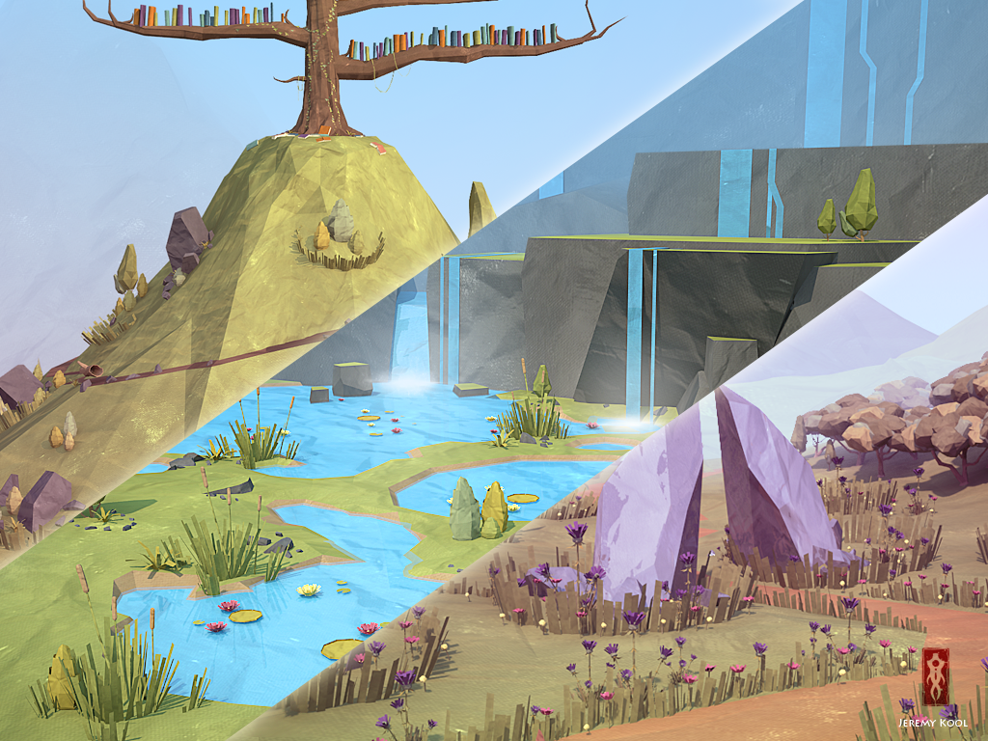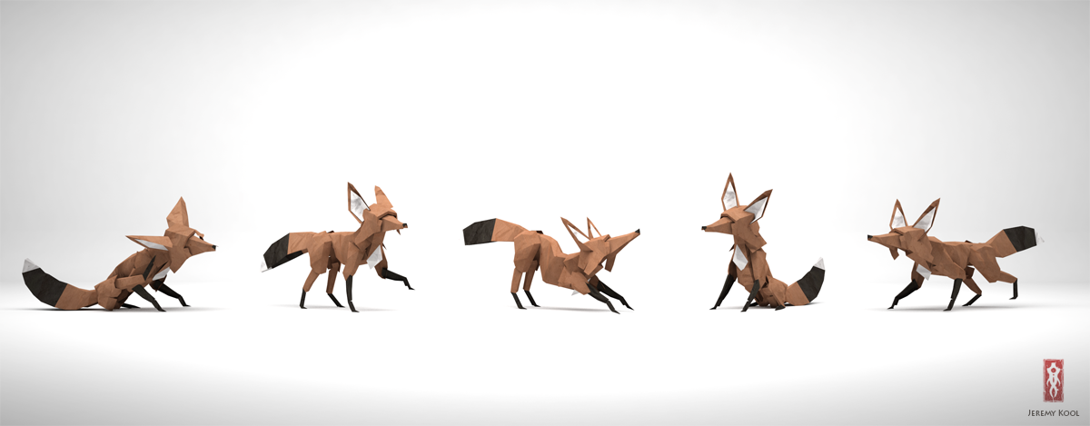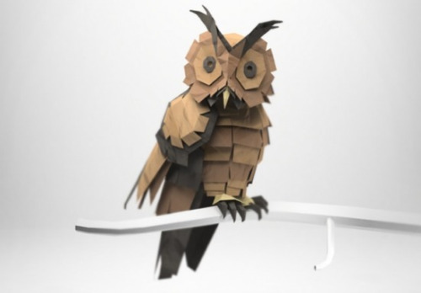(The following are examples that should be used as a reference when working on the character art and environmental art.)

**Features to be further discussed**

The following are features that need to be discussed more to determine how they should work in the game.

Rabbit panic status

Deity whistle and other possible abilities